**Notes for Git and GitHub**

What is Git ?

What is GitHub ??

**\*How to check in our computer git is installed or not ?**

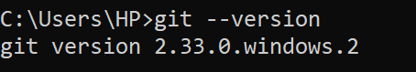

**\*How to create directory or folder using cmd??**

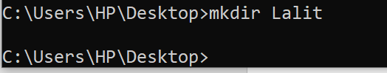

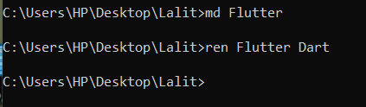

\***md** also is used to create folder using cmd and **ren is used to Rename the folder name**

**Flutter is old name and Dart is new name.**

**\*How to Remove folder using cmd ??**

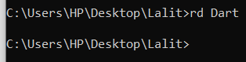

Note : Dart is folder name which folder want to remove.

**\*How to create nested folder using cmd?**

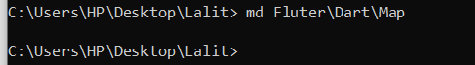

**\*How to move one Drive to another drive?**

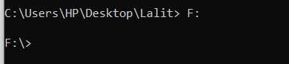

**Note :** F is the drive name.

**\*How to See all Items inside the F Drive?**

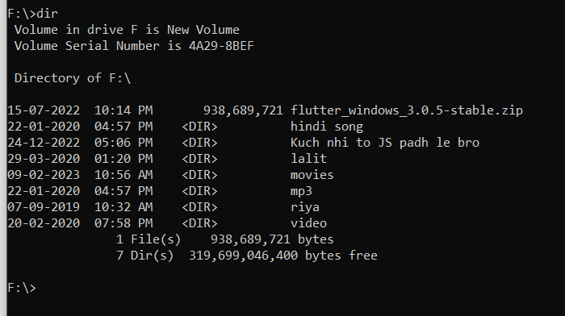

**\*How To rename the file but you Know the Extension of file then you can do this?**

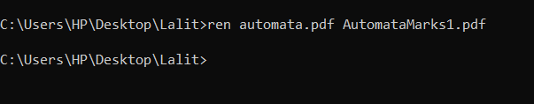

**\*\*\*How to move Parent to child and child to parent folder ??**

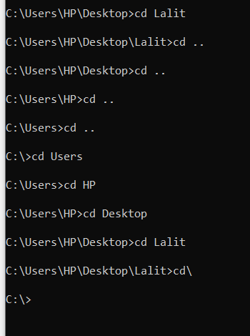

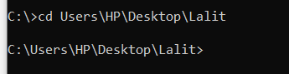

**1.cd is** used to move Parent to child folder.

2.**cd .. is used** to move first close parent from child folder, Lalit has Desktop first close parent folder

3.**cd\ is used to move last parent folder from child folder.**

**--------------------------------------------------------------------------------------------------------------------------------------------------------------------------------------------------------------------------------------------------**

**Lets Start the Git Commands -> All Commands are run Only git bush**

**How to set username and email before the using git?**

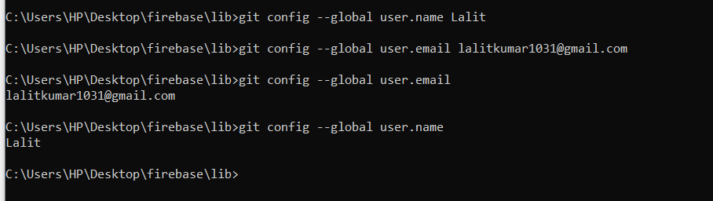

**\*\*How to clone any project from github using git cmd??**

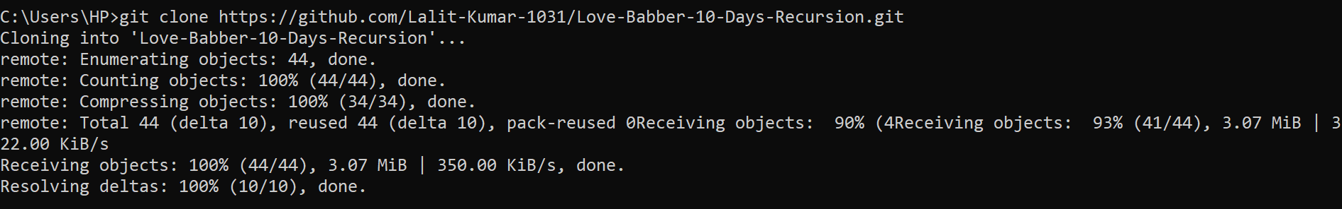

**1.git init cmd:**

are basically used for initialize the the git repo inside new project or existed project and appear a .git folder inside the project.

Note : Now firebase project are ready to use git commands.

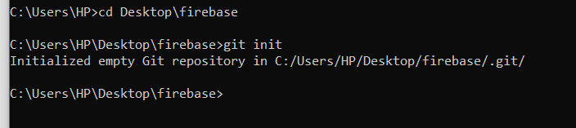

**2.git status :**

command are used to seen the status of your project and which file have inside the staging area or which file have not inside staging area and also tells which file are ready to commit or which file are not ready to commit.

**Important point :-**

**\*\*\*If you want to commit any file then firstly that file are added into staging Area then commit that file ,without adding staging area you can’t commit that file.**

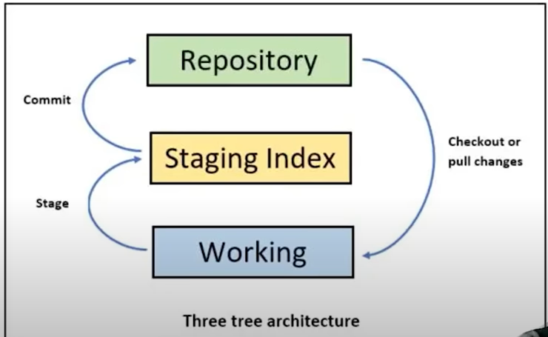

*These file are called untracked file that are not inside the staging area.

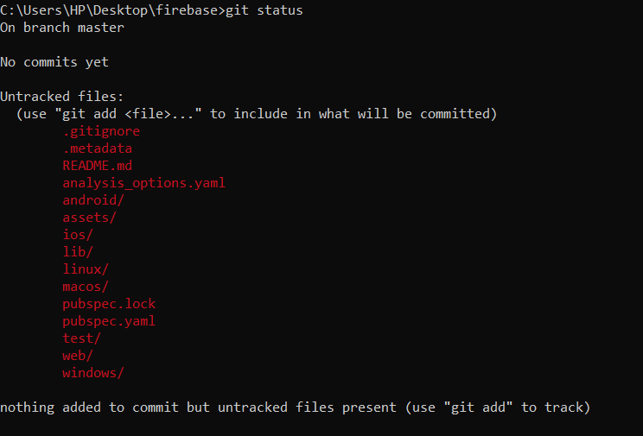

**3.git add**

git add command are used to add one or all files from non staging area to staging area.

**Command for all file add to staging area -> git add .**

**Command for add one file into staging area -> git add**

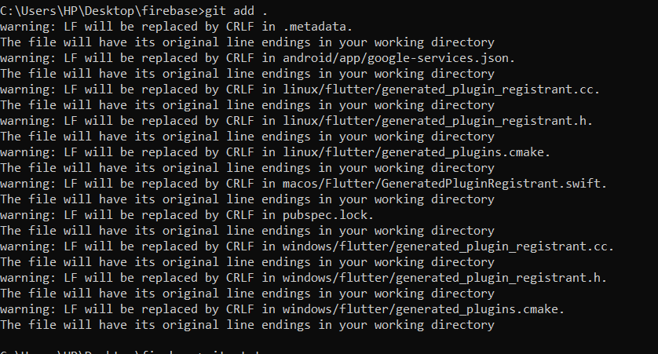

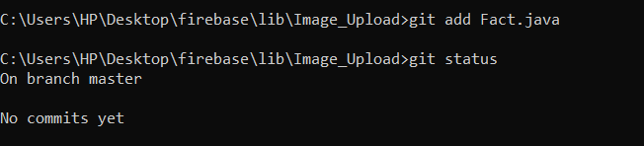

**4.git commit :** command are used to save the all changes in the file and all staging area files are move to local storage.

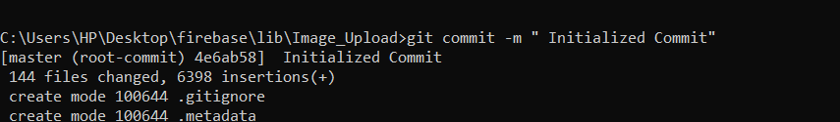

**6.git diff filename :-** This command are basically used for seen the changes in the particular files.

* Indicates which content are remove from the file and + indicates which content are added in the file.

**\*\*Comparison between Working directory and staging area file only.**

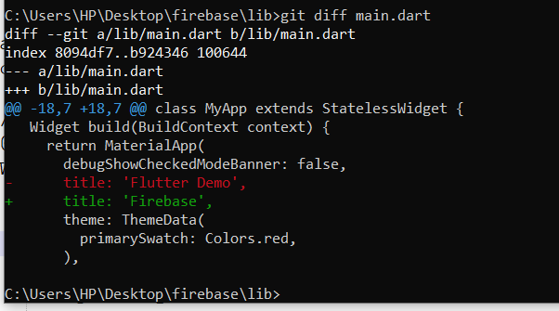

**\*\*How to see the changes between Staging area and last commit state.**

**\*Comparison between staging area and last commit.**

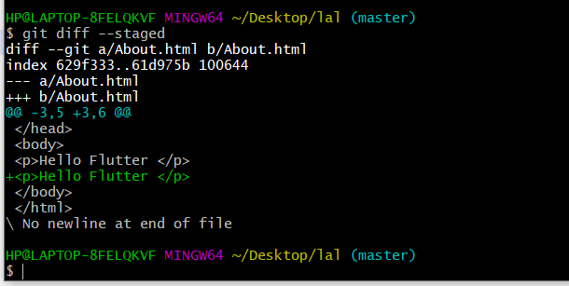

**7.git log command :**

This command are basically used for seen the all commit with username and date and also seen the commit id that id help to see the changes into file.

There are total 3 commit with commit id.

**ye Command run krne pr hamara cursor ajib state me chla jata h use normal state me lane ke liye Esc +wq press krke enter press krege

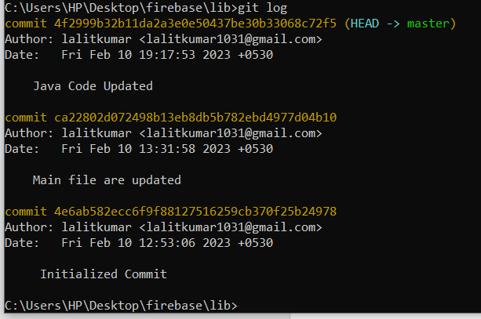

** **git log -2 are used to see the last 2 commit.**

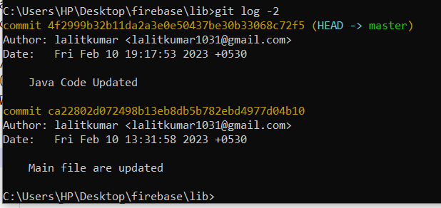

**8.How to see the changes into the file through commit id ??**

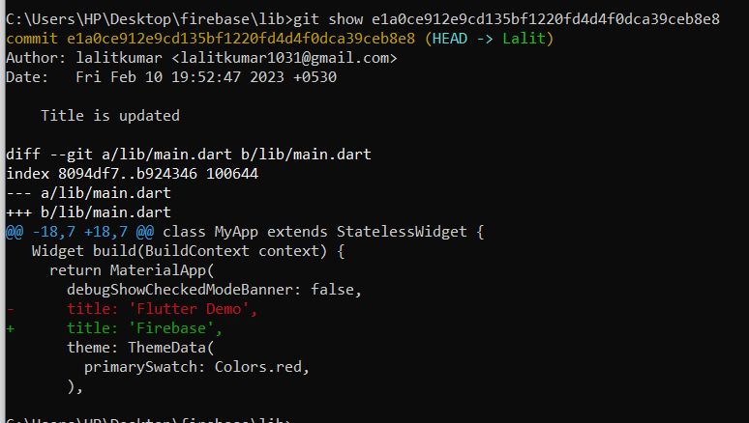

**9.How to create new branch and Lalit my new branch name and cursor or head currently into master branch (green color indicate this )**

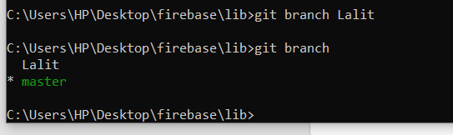

**10.How to see the status of the head or cursor??**

**Head currently onto the Lalit branch**

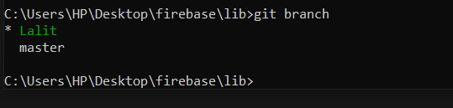

**11.How to switch one branch to another??**

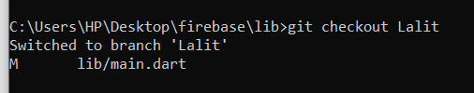

**Lalit is the destination branch.**

**13.How to delete a particular branch??**

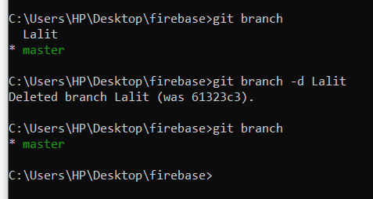

**12.How to create new branch and direct switch that branch with only one command??**

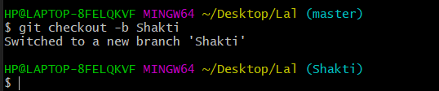

**12.How to merge the changes of Lalit branch into master branch.**

**Merge the Lalit branch into master branch

*Firstly go to master branch and run the merge command.

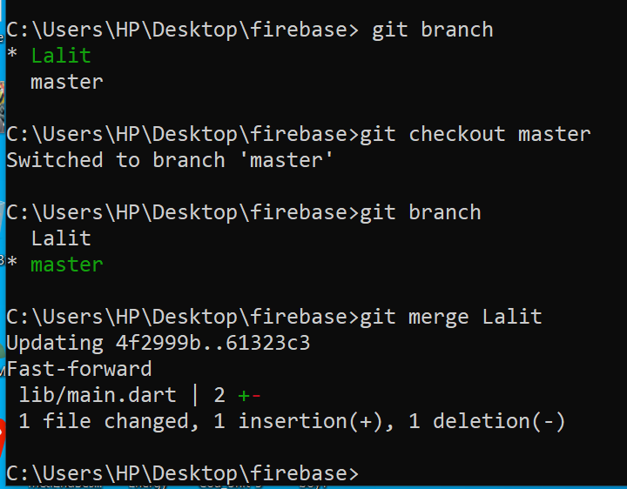

**13.How to show all the files with hidden files??**

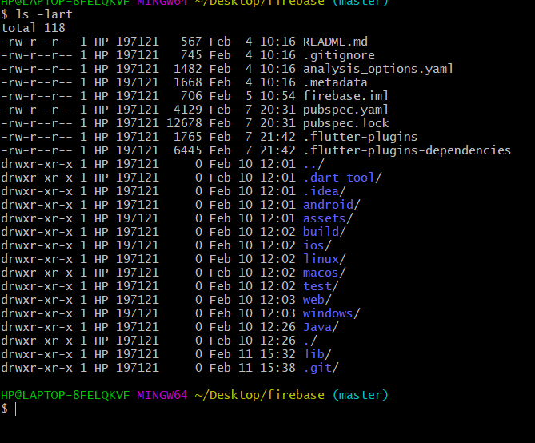

**14.How to create blank file using git bash??**

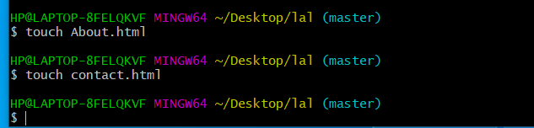

**15.When you work on project then suddenly someone are change your project code. At this moment how to recover the code changes simply use git checkout command. This command are used for redirect at last commit of your code.**

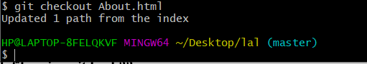

**16.This command are used for all files are recover by last commit.**

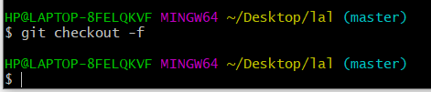

**17.How to commit a file without adding into staging area??**

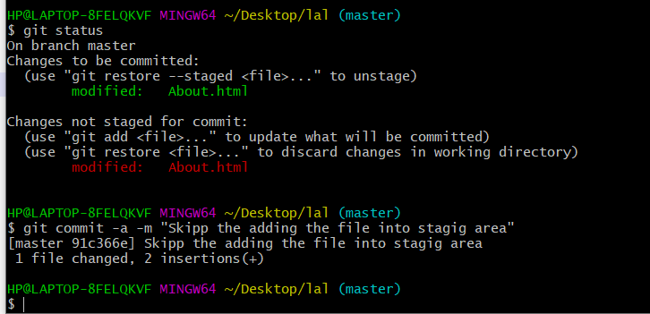

**18 .**How to delete the file from only working directory or only staging area or deleted both directory as well.**

**git rm -r . command are used to delete all the file from both directory.

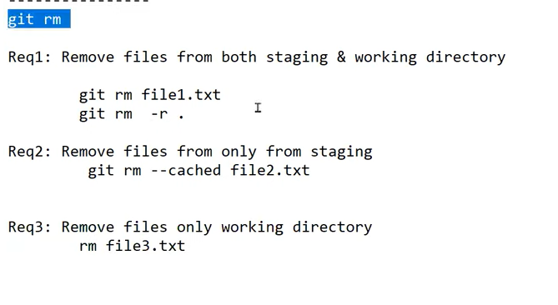

**19.How to show all the files inside the working directory??**

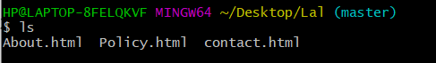

**20.How to show all the files inside the staging area??**

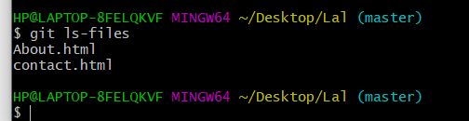

**21.How to make .gitignore file??**

**\*\***git ignore file are basically used for ignore some files. If you want to ignore some files by git then that file are mention into .gitignore file like this format

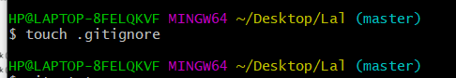

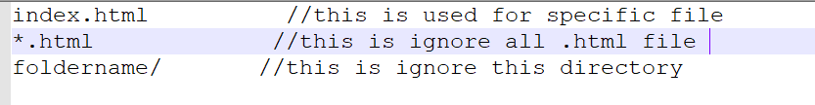

**22.How to push the project into github account with public repository??**

**Before the push any project into github account firstly create a repository

**push master branch into github account.

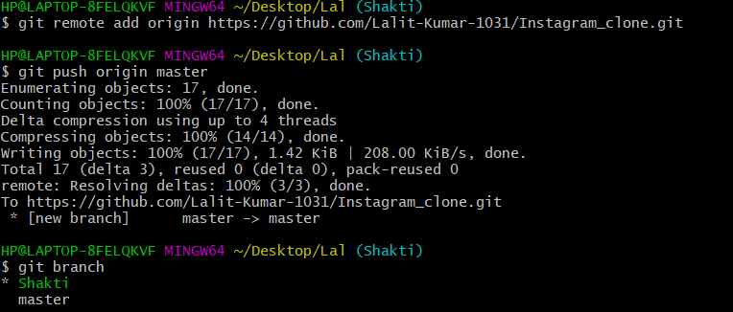

**23.How to push another branch into github account??**

